**Question # 01:** Write a program to evaluate the area and perimeter of rectangle. Ask user to supply length and breadth separately on the same line replacing the previous statement. Output screen should only print the answer in a comprehensive way e.g.

*The area and perimeter of rectangle with length = ______ and breadth = ______ are respectively ______ and ______ units.*

**Question # 02:** Areeba has a habit of collecting different country’s coins. Areeba has 7 Pakistani coins, 4 UK coins, 3 Indians and 3 Australian coins. Based on the input, identify how many international coins she has.

**Question # 03:**Write a program that asks user to give number of days as input and returns the number of years, weeks, and days. Assume every year has 365 days and every month is of 30 days.

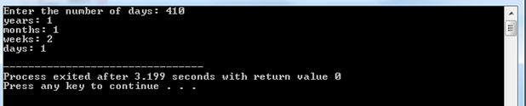

**Question # 04:**Generate the following output. (hint: ASCII value of ☺ is 1)

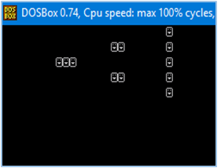

1. Write a program that asks user for temperature in Celsius and convert it into Fahrenheit.
2. Write a program that asks user for temperature in Fahrenheit and convert it into Celsius.

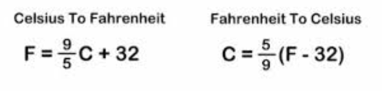

**(Note: There should be only 3 digits after the decimal point if output contains a fractional value)**

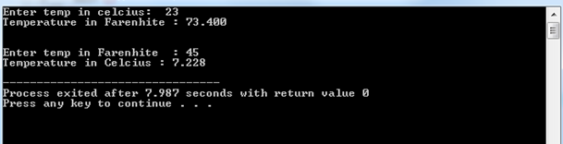

**Question # 05:** Write a C program to print rhombus star(*) pattern series. The pattern should look like:

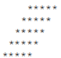

**Question # 06:** Write a program which takes two integers and interchange them without using additional variable.

**Question # 07:**Write a program which takes a character as an input and display corresponding ASCII code. Use that ASCII code and convert it into binary without using built in function.